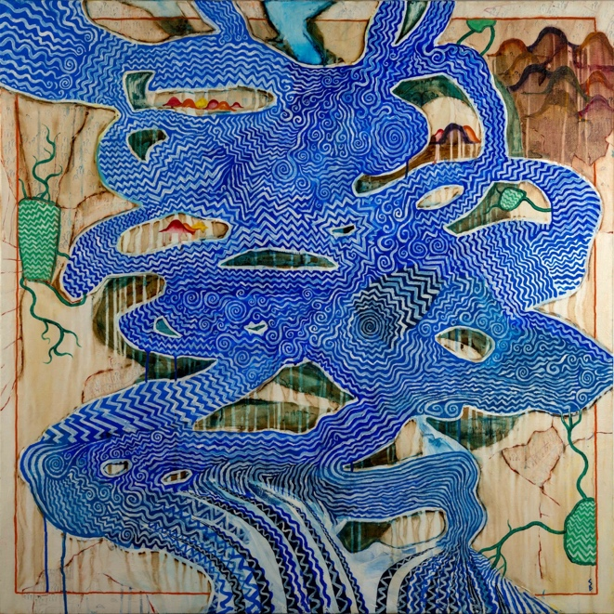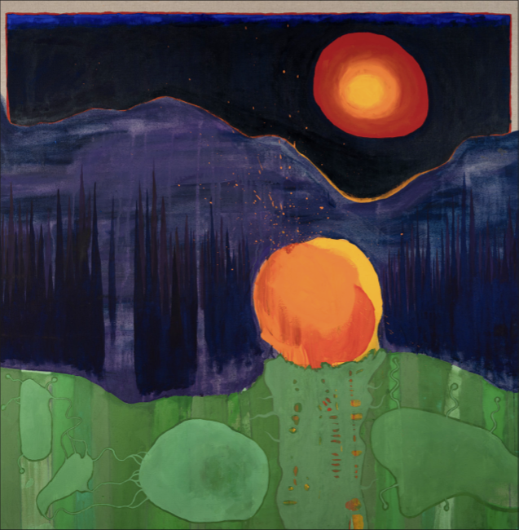
‘The Crow Flies’
An exhibition of new paintings by Stanley Donwood & Thom Yorke

4 Cromwell Place, London SW7 2JE
Part One: 6th-10th September 2023
Part Two: 6th-10th December 2023

A series of new large-scale paintings co-created by Stanley Donwood and Thom Yorke will be presented by TIN MAN ART in a two-part exhibition, the first of which is in September, with a follow up at the end of the year.
‘The Crow Flies’ marks an important moment in the duo’s 30-year association, with a series of artworks that were made by both artists literally side-by-side, painting at the same time.
This new style of artistic collaboration was first born out of last year’s critically acclaimed debut album A Light for Attracting Attention from The Smile, a new band comprising Thom Yorke, fellow Radiohead bandmate and film composer Jonny Greenwood and jazz drummer and member of Sons of Kemet, Tom Skinner.

Having first met Yorke when they were both art students, Stanley Donwood has provided the artwork for all of Radiohead’s albums and materials since 1995’s The Bends. His iconic paintings provide the first visual foray into Yorke’s music, both throughout the musician’s solo career and with his various band projects.
Beginning in 2021, Donwood and Yorke worked on these paintings while The Smile conceived, recorded and performed its debut album. In a complete example of co-creation, both artists worked on the canvases physically at the same time, often in a tiny studio setting. This differs from previous approaches, in which their artistic dialogue usually took place via faxes and notes. As well as providing album art, these sessions ultimately spanned two years and produced over 20 works that will now be exhibited to the public for the first time.
The artwork itself is closely linked with The Smile’s genesis. The band’s name is taken from Ted Hughes’s seminal poetry collection Crow, which also inspired the paintings and title of the exhibition. During the pandemic - when the public first became aware of Yorke’s new musical project - the accompanying artwork and animations that were posted with each new single became a source of speculation amongst fans, as they pored over hints and possible revelations regarding the forthcoming album.
Part of an on-going decades-long collaboration between the pair, this body of work draws on a fascination with maps and topography that can be seen from album artwork of 20 years ago; Radiohead’s Hail to the Thief (2003). Inspired by, among others 17th-century maps by Persian pirates, early drawings of the British Isles, and US military charts from the 1960s, Donwood and Yorke began their own versions.
At first the pair drew objects from the album’s lyrics to serve as a potential map legend, where symbol and text explain to the viewer what the map is showing. This approach was later discarded in favour of a more abstract technique, but some drawings can still be made out under layers of paint.
The process of map-making has also inspired this new series. Techniques of drawing and painting on vellum (calfskin) that were commonly used in historic map-making have led to a difference in approach, eschewing the digital processing that has categorised much of their previous work. Water-based gouache, egg tempera and powdered mushroom have been favoured over acrylic. The works are also considerably lighter in tone, a departure from earlier work such as Kid A Mnesia, with explosions of blue and a focus on gold, again influenced by the gold-leaf paint of centuries-old maps.
Reflecting on these materials, Yorke likened the art sessions to the process of making music, saying “that was what I found incredibly exciting. It just stays active for so long… I became so conscious of the fact that the two processes are almost exactly the same”. Observing the similarities between music-making and art production, they have also both referred to themselves as a ‘two-piece’, working side by side and responding to each other’s work in real time.
In this new method of working, the editing process is effectively withdrawn, but the paintings retain the familiar motifs and thematic elements that run throughout their artistic collaboration. From the stylised mountain backgrounds of Kid A (2000), to the twisted branches of The King of Limbs (2011), and the winding river-like roads of OK Computer (1997), ‘The Crow Flies’ is a continuation of a journey into a visual dreamlike landscape that has been charted for almost 30 years.
The exhibition will also include a Flemish woven tapestry of one of the key paintings, commissioned by the artists to celebrate the album’s one-year anniversary.
With over 20 works to include, the series will be exhibited in two parts.
James Elwes, TIN MAN ART Director, says: “Stanley Donwood and Thom Yorke’s 30-year artistic partnership has been culturally groundbreaking - and ‘The Crow Flies’ marks a momentous new chapter for them. This two-part exhibition showcases that rarest of achievements: pure co-creation. The paintings, sublime illustrations of technical and mental virtuosity, are the result of two artists working together to build worlds in gouache and gold. At a time of deep discord, this show reminds us of the awesome power of collaboration and the oft-misused term ‘genius’.”

NOTES TO EDITORS
HIGH RESOLUTION IMAGES FOR MEDIA USE CAN BE DOWNLOADED HERE
‘The Crow Flies’ is presented by TIN MAN ART
4 Cromwell Place, London SW7 2JE

Public Opening Hours:
- Wednesday to Saturday 11am – 7pm
- Sunday 11am – 4pm

For enquiries visit: www.tinmanart.com

Thom Yorke (b. 1968) is a musician, artist, composer and activist. He is best known as lead singer and songwriter of Radiohead; the group has won several Grammy and Ivor Novello Awards and has released critically acclaimed music. Radiohead’s work is widely regarded as some of the most celebrated and influential of recent decades. The band has been inducted into the Rock and Roll Hall of Fame and their work sits in the US Library of Congress. In addition to his work with Radiohead, he has released three solo albums, formed Atoms for Peace with Nigel Godrich, Flea, Joey Waronker and Mauro Rofosco, created the original soundtrack to Luca Guadagnino’s 2018 remake of Suspiria, and most recently, released work as The Smile, with Jonny Greenwood and Tom Skinner. In 2021, he co-created the KID A MNESIA Exhibition, with Stanley Donwood and producer Nigel Godrich, an interactive audio-visual experience with music and artwork drawn from the Radiohead albums Kid A and Amnesiac. Yorke and Donwood also released two books, KID A MNESIA and Fear Stalks The Land. The former celebrates the process and artwork created for Kid A and Amnesiac, the latter compiles notes, lyrics and sketches from that period. Yorke lives and works in Oxfordshire, England.

Stanley Donwood (b. 1968) was born in Essex, England. He studied English Literature & Fine Art at the University of Exeter where he first met Radiohead frontman Thom Yorke. The lifelong collaboration between band and artist was initiated when Yorke asked Donwood to contribute art for Radiohead’s original My Iron Lung EP (1994). Donwood’s paintings, drawings and prints address socio-political issues, often employing an element of satire. He has been the official artist of the Glastonbury music festival since 2002 and has won two Grammys for his artwork for Radiohead’s albums Amnesiac and In Rainbows. Donwood's art has been the subject of a book, There Will Be No Quiet (2019), published by Thames & Hudson. He has written and illustrated several books of short stories, including Humor (Faber, 2014). He has exhibited at galleries internationally. He lives and works in Brighton, England.
The artists are represented by TIN MAN ART. Founded in 2021, TIN MAN ART is a forward-thinking gallery that prizes invention, collaboration and transparency. It was founded on the basis that art should be enjoyable and open to all.
FOR MORE INFORMATION, INTERVIEWS AND IMAGES
Tracy Jones, Brera PR – tracy@brera-london.com / 01702 216658 / 07887 514984 / www.brera-london.com

